**Assisted Practice: 5.6 Insertion Sort**

This section will guide you to:

* Create a Java class in your IDE
* Implement the insertion sort algorithm in a predefined array
* Check if the element is available in the predefined array

This lab has three subsections, namely:

5.6.1 Writing a program in Java implementing the insertion sort algorithm

5.6.2 Executing the program to verify the execution of the insertion sort algorithm

5.6.3 Pushing the code to your GitHub repositories

**Step 5.6.1:** Writing a program in Java implementing the insertion sort algorithm

There are two ways you can perform this step; you can create a new Java project, or you can create a new Java class in the existing project. It is preferable to create a new Java class in the existing project but feel free to explore the first option. The steps mentioned below will work once you create a project in Java.

* Open Eclipse
* *[Right click]* on the **src** folder of the project
* Select *New* -> *Java Class* -> Enter the filename (follow camelCasing)
* Execute the code below resolving the warning and errors due compatibility-related issues

public class insertionSort {  
  
 public static void main(String[] args){  
  
 int[] arr = {9,12,3,21,44};  
 *insertionSort*(arr);  
 for(int i=0;i<arr.length;i++){  
  
 System.*out*.println(arr[i]);  
  
 }  
 }  
 public static void insertionSort(int[] arr){  
  
 int len = arr.length;  
 for(int j=1;j<len;j++){  
 int key = arr[j];  
 int i=j-1;  
 while ((i>-1) && (arr[i]>key)){  
  
 arr[i+1]=arr[i];  
 i--;  
 }  
 arr[i+1]=key;  
 }  
  
 }  
}

**Step 5.6.2:** Executing the program to verify the execution of the insertion sort algorithm

Before you execute the program, check for syntactical corrections. If no errors are found, follow the steps mentioned below:

* ***[Right click]*** in the program space
* Select *Run* ***‘insertionSort.main()’***

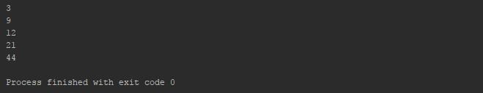

**Step 5.6.3:** Pushing the code to your GitHub repositories

* Open your command prompt and navigate to the folder where you have created your files.

**cd <folder path>**

* Initialize your repository using the following command:

**git init**

* Add all the files to your git repository using the following command:

**git add .**

* Commit the changes using the following command:

**git commit . -m “Changes have been committed.”**

* Push the files to the folder you initially created using the following command:

**git push -u origin master**